EZplot assignment (25points)

1. (3pts) Use ezplot to plot the following function in the closed interval [0,Aπ], $f\left(x\right)= e^{-0.1x}sin⁡(x)$. Using a function you define to input A and get an ezplot plot output.

function plot_ez(fig,a)

syms x;

y = exp(-0.1*x)*sin(x);

figure(fig);

ezplot(y,[0,a*pi]);

End

>>plot_ez(1,2); plot_ez(2,4)

* 1. The displayed domain of the function changes from 0-2pi, to 0-4pi. Though they are the same function—same amplitude, period, and exponential decay—the exponential decay is more apparent in the figure where more periods fit into the displayed domain.

1. (3pts) Use ezplot to plot the polynomial and its roots: $\left(x\right)=-2x^{2}+5x+4$. Turn the grid on. Label the roots lower root and upper root in the plot using text. You don’t have to find the actual values.
   1. f = -2*x^2+5*x+4; theRoots = roots(sym2poly(f))
      1. theRoots = (-0.6375, 3.1375)
   2. ezplot(f)
      1. 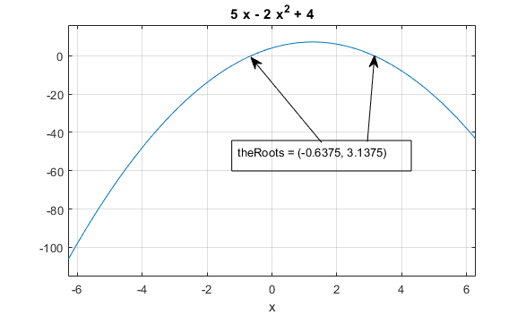
2. (3 pts) Use ezplot to plot the following function in the interval[-6,6], Set the limit for the y-axis to [-9, 9].

$$f\left(x,y\right)=-2x^{2} y^{2}+5 x^{2}y-4xy^{2}+16xy+4x+8y+16$$

syms x y; f(x,y)=-2*(x^2)*(y^2)+5*(x^2)*y-4*x*(y^2)+16*x*y+4*x+8*y+16; ezplot(f,[-6,6],[-9,9])

1. (3pts.) Use ezplot3 to create a 3D curve for the following relationship in the interval-[9pi,9pi]

$x=e^{0.1t}$ cos(t) $y=e^{0.1t}$ sin(t) $z=t$

ezplot3(x1,x2,x3,[-9*pi,9*pi])

1. (2pts) Use ezsurf and ezmesh to make a 3D surface plot of the following function $z\left(x,y\right)=6{(y^{2}-x^{2})}^{3}{+(1-y)}^{6}$

Syms x y; z(x,y) = 6*(y^2 - x^2)^3+(1-y)^6; ezsurf(z); ezmesh(z)

1. (2pts) Use ezpolar to plot the following: $1+2\sin^{2}⁡(2Φ), for Φ ∊[0,2π]$

polEquation = sym(‘1 + 2*sin(2*phi)’); ezpolar(polEquation)

1. (2 pts) Plot the contours of $f\left(x\right)=(\cos\left(x\right)cos⁡(y))e^{-\sqrt{\frac{x^{2}+y^{2}}{4}}}$

syms x y; f(x) = (cos(x)*cos(y))*exp(-sqrt((x^2 + y^2)/4)); ezcontourf(f)

1. (7 pts) Write a symbolic script to solve the following: Find the point when the curve $y=x^{3}-3x+4$ and $y=3(x^{2}-x)$ are tangent to each other, Illustrate by sketching both curves and the common tangent line. Comment on your script.